**CODE-A-THON**

**TITLE--- GOOGLE PAY CLONE**

**GOOGLE PAY CLONE USING WEB DEVELOPMENT**

**TEAM MEMBERS**

S.PUVIYARASAN-21BCA0040

V.ANANDAKUMAR-21BCA0064

V.SANKER-21BCA0067

G.HARIHARAN-21BCA0100

**OBJECTIVE:**

The objective for a Google Pay clone could be to create a seamless and secure digital payment platform that provides users with a user-friendly experience, supports a wide range of payment options, ensures the highest standards of security, and promotes financial inclusivity by reaching a diverse user base. The clone should aim to replicate the key features of Google Pay while incorporating any unique improvements or innovations that can enhance the overall user satisfaction and make it a preferred choice for digital transactions.the key features of Google Pay, the special innovation for this clone will be the integration of a user-friendly QR code generator for seamless money transfers.

**Brief overview of each module:**

1. Bank Transfer:

- Objective: Facilitate seamless and secure bank transfers within the app.

- Key Features: Users can link their bank accounts, initiate transfers to other users, set recurring payments, and receive funds directly into their linked accounts. The module ensures adherence to the highest security standards in financial transactions.

2. Transaction History:

- Objective: Provide users with a detailed record of their past transactions.

- Key Features: Users can view a comprehensive list of their transactions, filter by date or type, and access detailed information for each transaction. This module enhances transparency and helps users keep track of their financial activities.

3. QR Code Generator:

- Objective: Simplify and expedite money transfers using personalized QR codes.

- Key Features: Users can generate QR codes linked to their payment details. Recipients can scan these codes to initiate transactions without manual input. The feature is user-friendly, secure, and versatile, catering to various transaction scenarios.

4. Feedback:

- Objective: Gather user feedback to enhance the app's functionality and user experience.

- Key Features: Users can provide feedback on their experience, suggest improvements, and report issues. This module acts as a valuable tool for continuous improvement, ensuring that the app evolves based on user needs and preferences.

5. Settings:

- Objective: Empower users with control over their app preferences and account settings.

- Key Features: Users can customize app settings, manage notification preferences, update personal information, and configure security settings. This module enhances the user's overall experience by offering flexibility and personalization options.

**UML DIAGRAM:**

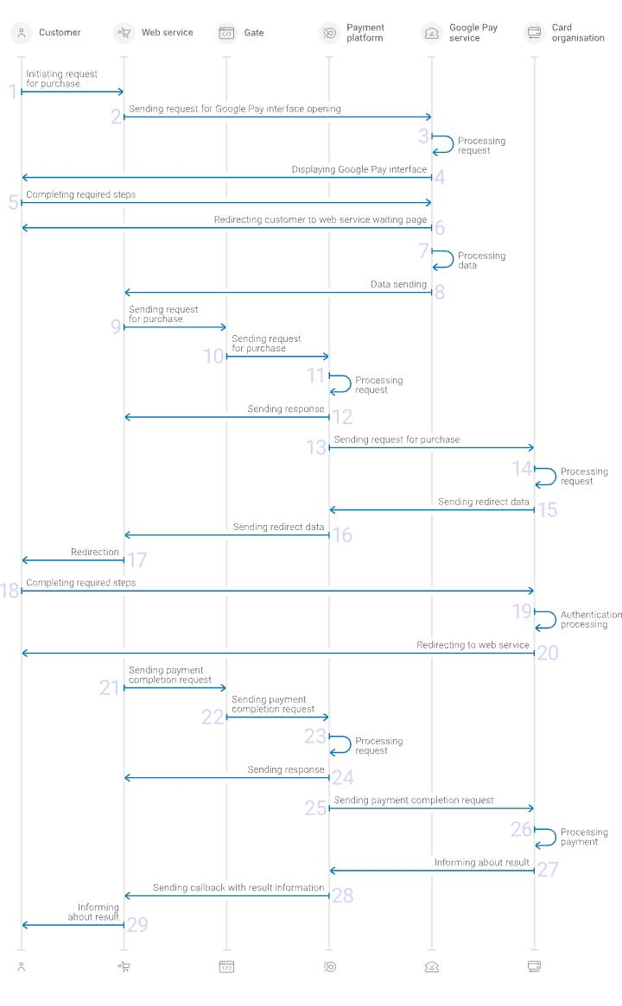

**OUTPUT SCREEN SHOT:**

